Set Theory

🌟 Definition
# Source: AI Source: Provided by: [Data Path: Persons Table -> ID Column: 1, Name_En Column: Motasem Essam] -> From: [ChatGPT] on [7/7/2026]
Set Theory is the branch of mathematics that studies sets, which are well-defined collections of distinct mathematical objects. It provides the fundamental language and framework used throughout almost all areas of mathematics.

🎯 Purpose
# Source: AI Source: Provided by: [Data Path: Persons Table -> ID Column: 1, Name_En Column: Motasem Essam] -> From: [ChatGPT] on [7/7/2026]
Set Theory is used to:
- Describe and organize mathematical objects
- Define mathematical structures
- Build mathematical theories
- Provide the foundation for modern mathematics
- Express relationships between collections of objects

📚 Important Symbols
# Source: AI Source: Provided by: [Data Path: Persons Table -> ID Column: 1, Name_En Column: Motasem Essam] -> From: [ChatGPT] on [7/7/2026]
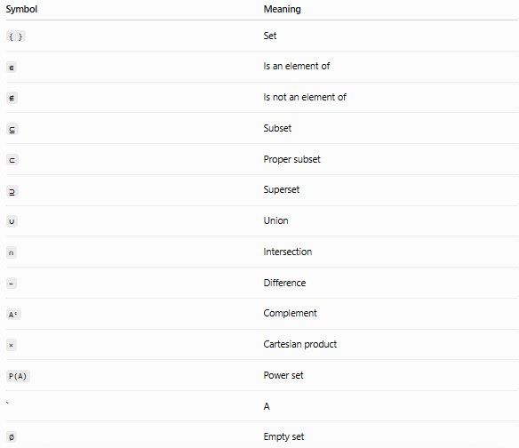
Symbol | Meaning
{ } | Set
∈ | Is an element of
∉ | Is not an element of
⊆ | Subset
⊂ | Proper subset
⊇ | Superset
∪ | Union
∩ | Intersection
− | Difference
Aᶜ | Complement
× | Cartesian product
P(A) | Power set
` | A
∅ | Empty set

🛠 Applications
# Source: AI Source: Provided by: [Data Path: Persons Table -> ID Column: 1, Name_En Column: Motasem Essam] -> From: [ChatGPT] on [7/7/2026]
Set Theory is used in:
- Mathematical Logic
- Algebra
- Geometry
- Calculus
- Topology
- Probability
- Statistics
- Computer Science
- Database Systems
- Artificial Intelligence

🧠 Simple Analogy
# Source: AI Source: Provided by: [Data Path: Persons Table -> ID Column: 1, Name_En Column: Motasem Essam] -> From: [ChatGPT] on [7/7/2026]
Think of a set as a box.
- The box is the set.
- The objects inside the box are its elements.
- Set operations describe different ways to combine, compare, or organize these boxes.

🧭 Summary
# Source: AI Source: Provided by: [Data Path: Persons Table -> ID Column: 1, Name_En Column: Motasem Essam] -> From: [ChatGPT] on [7/7/2026]
Set Theory is the branch of mathematics that studies sets and the relationships between them. It provides the foundational language of modern mathematics and introduces concepts such as elements, subsets, unions, intersections, Cartesian products, power sets, and cardinality, which are used throughout nearly every area of mathematics.

